Using water-hyacinth extraction as substrate for biogas production

Suchat Leungprasert*¹⁾, Kodchakorn Thuanthon²⁾, and Peerakarn Bunjerdkit¹⁾,
¹⁾ Environmental Engineering Department, Faculty of Engineering, Kasetsart University, 50 Ngamwongwan Road, Ladyao, Chatuchak, Bangkhen, Bangkok, 10900, Thailand
²⁾Master Student, Environmental Engineering Department, Faulty of Engineering, Kasetsart University
* fengscl@ku.ac.th
Keywords: Anaerobic process; organic loading; cow dung; methane production
Introduction
Water-hyacinth is one of the biggest problems in Thailand due to its rapidly growth. It can cause many problems including blocking the vehicle traffic along the river, reducing water quality, and etc. It also can cause flooding. Several methods were used to remove the water-hyacinth including the composting process, mushroom production, animal feeding, and etc. However, these methods are still unsuitable in terms of cost-benefit.
Since, the renewable energy policy was launched by Thai government. The study of water-hyacinth used as the energy source was interested due to its high quantity in the environment. The direct use of water-hyacinth as the material for biogas production was studied in anywhere. However, it was found that the rate of biogas production was not high due to high cellulose in its body. In addition, the water-hyacinth contains high amount of moisture content. It is required to make it dry before using as the biomass fuel. This may need a huge area. As a result, this study will be focus on the extraction of the water-hyacinth and use it as the carbon source in anaerobic process for biogas production. The remaining part can be used for the biomass.
Material and Methods
The water-hyacinth was collected from the canal and was extracted by using blending machine. The extracted water was kept in the refrigerator before adding into the reactors. Cow dung was used as the seeding to increase the microorganisms in the system.
To prepare the appropriate microorganisms, 1 L of cow dung was added into the 5-L reactor as shown in Figure 1.1. The, 1 L of the extracted water was added every three days until the total volume was 5 L. This mixture was left for 10 days to make sure that the anaerobic microorganisms are acclimatized with the extracted water.

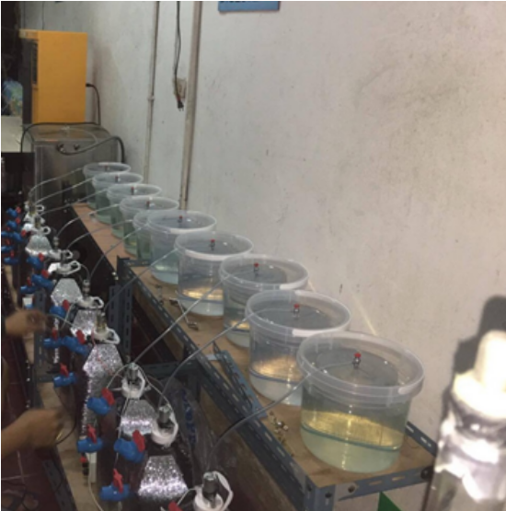
Figure 1.1 The laboratory scale experiment reactors

The experiments were start up by adding 0.5 L, 0.7 L and 0.9 L of the extracted water into the acclimatized reactor every day. The semi-continuous feed was used in these experiments. As a result, the hydraulic retention times were varied from 5.55 to 10 days. Also, the organic loadings were varied from 1.63 to 2.94 kg-COD/m³.d. The volume of biogas productions were measured by water replacing. Also, the biogas was collected to measure for % CH₄. In addition, COD, TS and TVS were daily analyzed from the mixing materials in each reactor. These results were used to determine the removal efficiency of the water-hyacinth extraction and biogas production.
Results and Conclusions
The characteristic of extracted water-hyacinth and cow dung were analysed as shown in Table 1.1. It was found that there is high concentration of COD, TS, and TVS with slightly low pH from the extracted water and cow dung. As a result, this wastewater might be appropriated to use as the substrate for the biogas production.

Table 1.1 The extracted water-hyacinth characteristic and cow dung.
Parameters | Unit | The extracted water-hyacinth | Cow dung
COD | mg/L | 16,368 | 28,800
TS | mg/L | 15,965 | 53,570
TVS | mg/L | 7,160 | 37,340
TKN | mg/L | 610 | 706
pH | - | 6.67 | 7.96
ORP | eV | -148.1 | -178.50
C/N ratio | - | 26 | -

After adding the extracted water for 100 days, it was found that the biogas production varied as the organic loading. The biogas volumes were levelled at 765, 676 and 575 ml/day for 1.63, 2.29 and 2.94 kgCOD/m³.day, respectively. This result shows that the biogas volume reduced when the organic loading increased. This may cause by the effect of high organic loading on the degradation of organic matter under anaerobic condition (Göblös et al., 2007). In addition, % methane productions were evaluated. It was found that % methane productions were approximately 70.93, 52.83 and 45.16 % for 1.63, 2.29 and 2.94 kgCOD/m³.day, respectively. This is confirmed that at the higher organic loading the % methane production was less than the lower organic loading. The % methane production of 50-75% was in the range of anaerobic digestion (Seadi et al., 2008). As a result, the suitable organic loading for the extracted water-hyacinth should be 1.63 kgCOD/m³.day.
The relationship between the methane production and COD removal was about 104.50, 71.66, and 51.26 L CH₄ at STP/kgCOD degraded for 1.63, 2.29 and 2.94 kgCOD/m³.day, respectively. This production is still low. McCarty (1964) said that the methane production should be 350 L L CH₄ at STP for 1 kgCOD degraded in theory. This could be showed that it is possible to increase the methane production for the extracted water-hayacinth.
In addition, the anaerobic process was operated at the temperature of 29-30ºC. Although the temperature of the extracted water was increased before adding the reactors, the inside temperature was still low. This may occur by improper control for the heat loss from the reactor. It may result to the lower volume of biogas production. To increase the biogas production, the temperature of the reactor should be 35 – 37ºC (Kim et al., 2006). As a result, the further experiments will be operated under the temperature of 30-40ºC and 50-55ºC to find out the effect of temperature on the biogas production.
In conclusion, the extracted water-hyacinth can be used as the substrate in anaerobic process to produce the biogas with high % methane. However, the biogas amount is still low compare to the COD removal.
References
Göblös, S., P. Portörö, D. Bordás, M. Kálmán and I. Kiss. 2007. Comparison of the effectivities of two-phase and single-phase anaerobic sequencing batch reactors during dairy wastewater treatment. Renewable Energy 33 (2008): 960–965.
McCarty, P.L. 1964. Anaerobic waste treatment fundamental part one - Chemistry waste and microbiology. Public Works 95 (9): 107-112.
Seadi, T.A., D. Rutz, H. Prassl, M. Köttner, T. Finsterwalder, S. Volk and R. Janssen. 2008. Biogas Handbook. University of Southern Denmark Esbjerg, Denmark.

